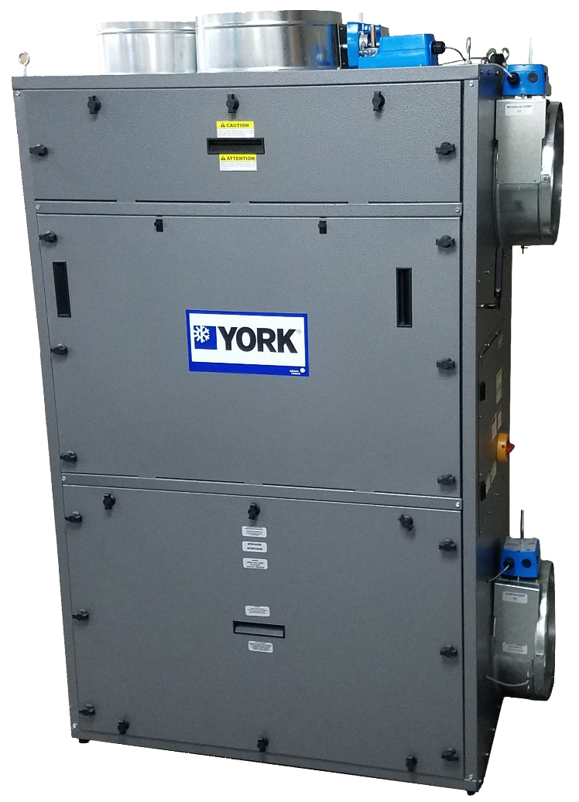

YORK® EcoAdvance™ 1000E
Technical Specifications

May 20, 2016
v3.1
© Johnson Controls, Inc. All rights reserved.

Table of Contents

YORK® EcoAdvance™ 1000E Module Overview 2
Weight and Dimensions 4
System Block Diagram 5
Electrical Panel 5
a. Power Requirements 5
b. Communications 6
c. Fans & Heaters 6
d. Required Built-in Connections 6
e. Additional Built-in Connections 7
f. Sensors 7
Installation Specifications 8
Support 9

YORK® ECOADVANCE™ 1000E Module Overview
The YORK® EcoAdvance™ 1000E air treatment system for HVAC load reduction works in all types of buildings, HVAC configurations, and climates. Each module has the following built-in components:
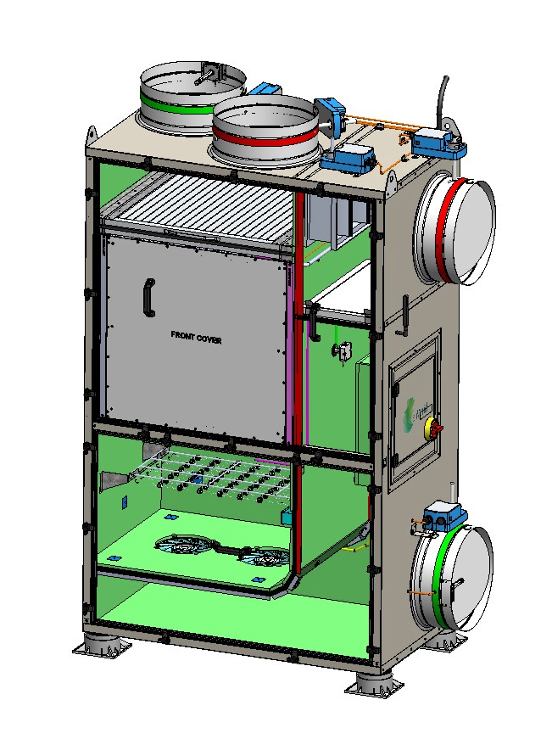

B. Heater

A. Cartridge
Bank

C. Fans

F
.
Control Board

D.
Inlets and Outlets

G
. Sensors
Quad Sensor
)
(

E
.
Shunt

H. Insulation
)
shown in green
(

D.
Inlets and Outlets

- Cartridge Bank – The cartridge bank houses 12 polypropylene cartridges that contain the sorbents used to capture contaminants (CO₂, formaldehyde, VOCs and PM_{2.5}) during the sorption (cleansing) cycle and then release them during the regeneration (outdoor purge) cycle.

- Heater – An integrated heater raises the internal temperature of the YORK® EcoAdvance™ 1000E to initiate the release of captured contaminants. During this phase, all external dampers are closed, and air is recirculated inside the YORK® EcoAdvance™ 1000E to accelerate the release process.

- Fans – Integrated DC brushless fans control airflow through the YORK® EcoAdvance™ 1000E during the sorption and regeneration cycles. Speed control and active feedback from the fans verify proper operation.

- Inlets and Outlets – The YORK®EcoAdvance™ 1000E module has two circular inlets and two circular outlets controlled by dampers. The inlets that route the air during sorption are highlighted in green in the schematic above. The outlets that route the air during the purge portion of the regeneration cycle are highlighted in red.

- Shunt – The internal shunt used during the heating portion of the regeneration cycle is controlled by a damper that is open only when all other dampers are closed.

- Control Board – The electronic enclosure contains the YORK® EcoAdvance™ 1000E power supply and controller board. The power supply converts the incoming AC power to the voltages required to operate all aspects of the unit. The controller contains the systems software, all controls/relays/sensor interfaces, and all wireless and wired communication modules.

- Sensors – The YORK® EcoAdvance™ 1000E unit contains three integrated internal multi-sensor modules used to measure temperature, humidity, CO₂ concentration, formaldehyde, and VOC levels during the sorption and regeneration cycles. The YORK® ECOADVANCE™ 1000E has two additional temperature and humidity sensors for monitoring the incoming outside air and the supply air from the air handling unit (AHU) to the conditioned space.

- Insulation – The inside walls of the YORK® EcoAdvance™ 1000E unit are covered in heat-reflective insulation material for improved efficiency and soundproofing.

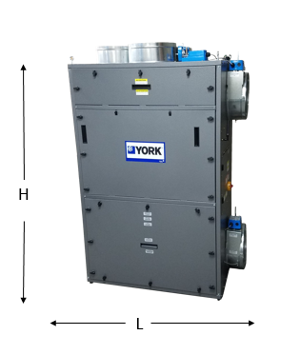

Weight and Dimensions

Weight | lbs (kg)
Unit Cabinet | 200 (90.7)
Unit with Cartridge Set | 400 (181.4)

Dimensions | Unit with dampers and handles | Unit
Length (L) | 48.82” | 44.76”
Width (W) | 26.01” | 25.33“
Height (H) | 74.64” | 69.04”

System Block Diagram
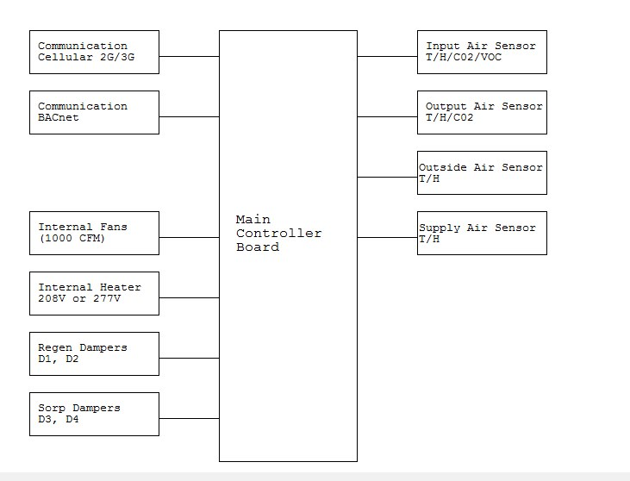

Electrical Panel

a. Power Requirements
The YORK® EcoAdvance™ module is designed to work with single-phase AC power and can accommodate a range of line voltages and frequencies.
Voltage In (Vac) | MCA* | MOCP*
277 | 30.58 | 35.00
240 | 26.66 | 30.00
230 | 25.61 | 30.00
220 | 24.55 | 25.00
208 | 34.30 | 35.00
*MCA - minimum current ampacity; MOCP - maximum over-current protection

b. Communications
Each YORK® EcoAdvance™ 1000E module includes state-of-the-art wireless communication capabilities for ongoing monitoring and reporting of indoor air quality, sorbent performance, and system operating conditions.
Communications | Cellular Link | 2.5G/3G
 | Wireless Link | 915 MHz

c. Fans & Heaters
Powerful, lightweight, digitally controlled fans and an integrated heater deliver an effective and efficient variable airflow solution.
 |  | Voltage/Power
Air Flow Components | Fan(s) | 24VDC/120W (each)
 | Heater with PID control | 277VAC/6.5kW  208V/5.5kW

d. Required Built-in Connections
The YORK® EcoAdvance$™$ 1000E interfaces to the AHU using the following required built-in connections:
- Outside Air Damper Actuator – The YORK® EcoAdvance™ 1000E must take control of the outside air (OA) damper actuator to facilitate energy savings and load management.
- Outside Air Damper Reading – The YORK® EcoAdvance™ 1000E must read the position signal from the OA damper in order to set it to the correct position.
- Fire Signal – The fire signal is commonly generated from the fire panel or building automation system in the event of a fire in the building. It places the outside air damper, the YORK® EcoAdvance™ 1000E, and other air-handling devices in a mode that inhibits smoke/fire from spreading throughout the building through the air ducts.

- Air Handler Mode – The YORK® EcoAdvance™ 1000E operates in conjunction with the AHU.
Connections | OA Damper Control | Output from YORK® EcoAdvance™ 1000E: 2-10 VDC
 | OA Damper Position  Monitoring | Output from YORK® EcoAdvance™ 1000E: 2-10 VDC
 | Fire Signal Dry Contact Input | Input to YORK® EcoAdvance™ 1000E
 | AHU Mode Input | Input to YORK YORK® EcoAdvance™ 1000E

e. Additional Built-in Connections
Connections | AHU Fan Speed Input | Input to YORK® EcoAdvance™ 1000E
 | BAS* Open OA Damper Input | Input to YORK® EcoAdvance™ 1000E
 | BAS Close OA Damper Input | Input to YORK® EcoAdvance™ 1000E
 | Energy Meter Dry Contact  Input | Input to YORK® EcoAdvance™ 1000E
 | Available 24V Relay Output | Output from YORK® EcoAdvance™ 1000E 24V/1A
 | Available Dry Contact Output | Output from YORK® EcoAdvance™ 1000E 1A (max)
 | Available Dry Contact Input | Input to YORK® EcoAdvance™ 1000E
*BAS - Building Automation System

f. Sensors
 | Sensor Function | Location | Measurement*
Multi Sensor | Measures incoming air | YORK ECOADVANCE Interior | T, RH, C0₂, IAQ
Multi Sensor | Measures outgoing air | YORK ECOADVANCE Interior | T, RH, C0₂
TRH Sensor - AHU | Measures energy use | SA Duct | T, RH
 |  | OA Duct | T, RH
Pressure Sensor | Measures pressure | YORK ECOADVANCE Interior | P
Sorbent Temp | Measures temperature during regeneration | YORK ECOADVANCE Interior | T
*Legend: T (temperature); RH (relative humidity); IAQ (Indoor Air Quality); P (pressure)

Installation Specifications
The YORK® EcoAdvance™ 1000E is designed for simple, turn-key installation with physical dimensions that enable each unit to fit through a standard doorway and in a standard elevator. The lightweight module’s footprint provides for easy transport and positioning.

Three Installation Requirements
- Electrical power
- A built-in wireless data connection
(A cable must be hooked up during installation for a wired connection)
- Air duct connections: Round control dampers enable quick and cost-effective installation to ducts without transitions.
The YORK® EcoAdvance™ 1000E has a durable finish, sturdy construction, and reflective insulation, making it compatible with indoor installations. The modules can be located anywhere near the AHU, in the building’s mechanical rooms. Modules can be installed vertically or horizontally for easy side-by-side retrofit to existing HVAC infrastructure.
The YORK® EcoAdvance™ 1000E is designed to handle up to 1000 CFM (cubic feet per minute) of air in a slipstream configuration drawn from the return air path of the HVAC system. The number of modules required for any given building is determined by multiple considerations including contaminant sources, floor space, occupancy, exhaust systems, and building pressurization. A general guideline for office buildings is one YORK® EcoAdvance™ 1000E for approximately every 20,000 square feet of floor space; however, only a qualified YORK® EcoAdvance™ installation professional can determine the correct number and configuration of units required.
Two Installation Options

Ducted Return
The YORK® EcoAdvance™ 1000E module is designed for a slipstream topology—a unique feature of the YORK® EcoAdvance™ solution.
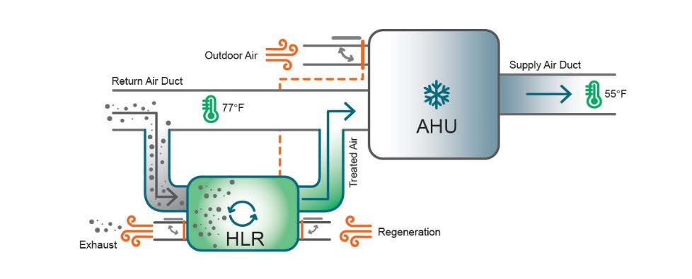

Slipstream topology allows the system to go offline for regeneration or maintenance without any disruption to the building’s ventilation systems. The inlet and the outlet of the YORK® EcoAdvance™ 1000E module are independently ducted to the indoor air ducts. The flow rate through the YORK ECOADVANCE 1000E is a small fraction of the total circulation and varies by indoor contaminant load.

Plenum Return
In plenum-based return air systems, the YORK® EcoAdvance™ module can be positioned inside the plenum with no ductwork for the indoor air. The module pulls in air from the plenum and ejects treated air back into the plenum. In this type of installation, the purge air inlets and outlets must be ducted to an appropriate outside air source and exhaust, respectively.
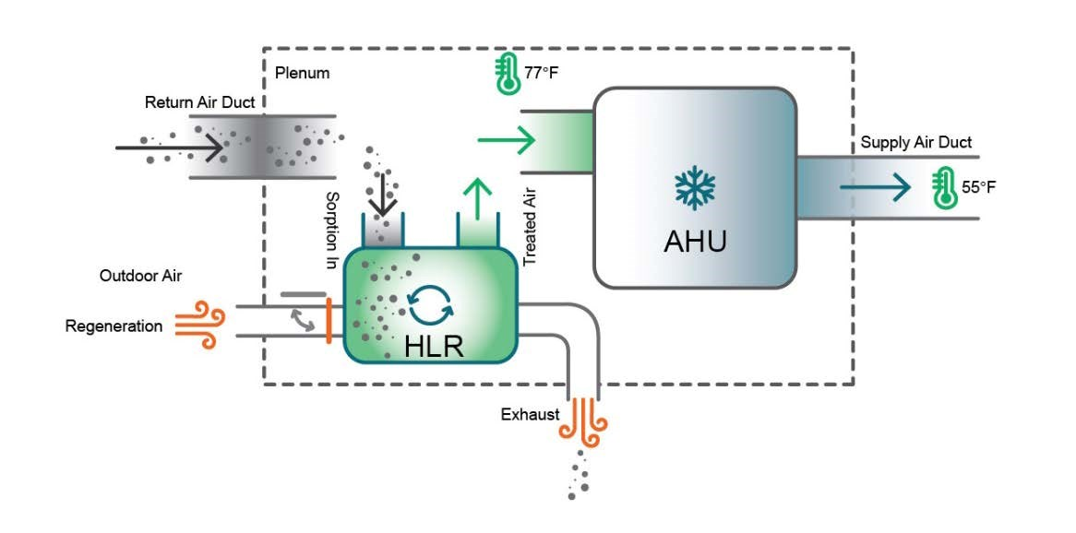

Basic Installation Steps
- Bring the YORK® EcoAdvance™ 1000E and cartridges to the installation area. Note: transport the YORK® EcoAdvance™ 1000E and cartridge set in their separate shipping containers
- Unpack the YORK® EcoAdvance™ 1000E and place the module in the orientation required for your installation.
Note: the YORK® EcoAdvance™ 1000E operates in either a horizontal or vertical configuration.
- Remove the upper door exposing the cartridge compartment.
- Install the cartridges per the installation instructions.
- Install the upper door, closing the cartridge compartment.
- Connect the four (4) required ducts. Note: All ducts are standard round 14-inch style.
- Connect the two (2) remote sensors to the YORK® EcoAdvance™ 1000E unit per the installation instructions.
- Connect AC power to the YORK® EcoAdvance™ 1000E unit per the power requirement instructions.
- Turn on the YORK® EcoAdvance™ 1000E unit using the front panel power switch.
- Complete the commissioning and testing procedure per the installation instructions.
Consult the installation manual and any relevant national and local codes as required.

Support
For additional support required during installation or operation, please contact enVerid Technical Support.
Due to ongoing product development and improvements, the specifications contained herein are subject to change without notice.

