Intro Section

International Materials Data System (IMDS) – Material Data Management

Introduction:
Government and industry regulations, including environment, safety, corporate governance and product performance are being enforced around the world. The IMDS (International Material Data System) is an internet-based database that has been established by the OEMs (Original Equipment Manufacturers) for free-of-charge use by all suppliers of the automotive industry. IMDS tracks chemical ingredients of parts and assemblies across the entire automotive OEM supply chain. The solution helps OEM’s to comply with the increasing number of national and EU regulations related to material handling and disposal.

International Material Data Systems - IMDS Requirements:
All suppliers of Johnson Controls, Inc. that provide direct material production parts and or assemblies are expected to comply with IMDS requirements:

- The IMDS declaration (IMDS data sheet) is a mandatory part of the PPAP procedure. PPAP documents without IMDS information will not be approved.
- Supplier Submission requests are post business award.
- Timing for Supplier IMDS submission is defined in the SSOW (Supplier Statement Of Work) in the program timing section - by the program manager.
- Suppliers declare the materials / substances used in each component part number.
- Submissions to the material data system must be an identical match to the part numbers defined in JCI systems (e.g. EPIC/MFG-Pro).
- The IMDS submission has to include the corresponding supplier code defined in the Purchase Order document.
- Supplier is expected to have correct IMDS contact information defined in the IMDS system.
- Supplier is expected to submit the IMDS datasheets to one of the below mentioned JC IMDS company ID depending on the respective JC plant / region.

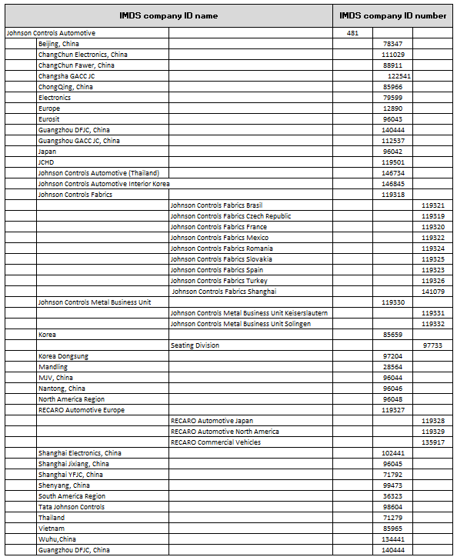

Scope of IMDS Requirements for Johnson Controls Suppliers:
- New program launches
- Engineering changes
  - Change in weight
  - Change in part number
  - Change in supplier
  - Change in material
- Service parts
- Legal changes in respect to the substance restrictions (e.g. ELV, GADSL, etc)
- OEM changes in respect to the substance restrictions

IMDS Deliverables & Timing – Supplier Submission Expectations:
- The supplier is expected to submit IMDS per the specified date by the Johnson Controls program manager or upon email request post supplier award.
- The supplier is expected to respond to the initial request by committing to a submission date within 2 business days of the Johnson Controls IMDS department request.
- The supplier is expected to submit material data into the IMDS system within 4 weeks of the request prior to supplier part approval.

North America IMDS Submission Location:

Supplier information: Please submit the IMDS entries to the following IMDS Company IDs:
KEIPER programs (globally) submit to IMDS# 119331
CRH programs (globally) submit to IMDS#119332
RECARO programs (NA only) submit to IMDS# 119329
JCI NA programs/plants submit to IMDS #96048

Please note, that the former JC NA IMDS Company ID 630 is no longer valid as of April 1st, 2013.

Access to the material data system: http://www.mdsystem.com

Material data system help desk imds-helpdesk-americas@hp.com

For any further IMDS related questions please visit the IMDS Information pages:

https://public.mdsystem.com/en/web/imds-public-pages;jsessionid=A354E97364A7FE9C90D39C5A959D0FDB

Johnson Controls North America - IMDS Submission Team

IMDS service for all NA programs is being provided by the JC IMDS center department located in Europe. Main contacts are:

AE Seating Global:
Bibiana Prazenicova, Engineering Manager, Bibiana.Prazenicova@jci.com (+421 918 787 626)
Thomas Janega, Lead Engineer, Thomas.Janega@jci.com (+421 918 787 639)

AE Interiors Global:
Daniela Demjanovicova, Chief Engineer, Daniela.Demjanovicova@jci.com (+421 918 787 656)

The regional NA IMDS contacts are:

AE Seating group:
Douglas M Henry, IMDS Specialist, Douglas.M.Henry@jci.com (+1 734 254 5882)

AE Interiors:
Terry A Vanderlee, Engineering Manager. Terry.A.Vanderlee@jci.com (+1 616 394 6129)
Dee Ruggles, IMDS Specialist, Dee.Ruggles@jci.com (+1 734 254 3418)

